Task 2: Test log
Description of test | Test data to be used (if required) | Expected outcome | Actual outcome | Comments and intended actions
Test if Products are displayed on the home page. | None | Each product is displayed with a matching image and name. | Every product has an image and matching name. 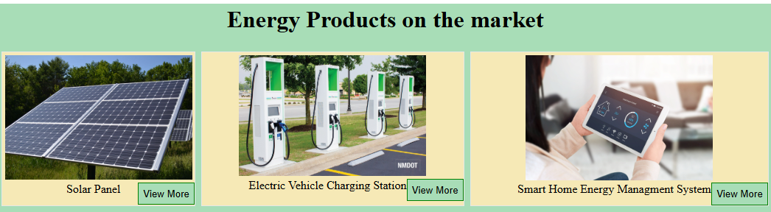 | None
Test View More button functionality. | View more button clicked. | Button opens a pop-up window. | The button opens a pop-up window. | None
Test View More Pop-up window display. | None | Each View More button displays a pop-up with the name of the product, description, and price. | All of the View More buttons display a pop-up with correct information about each product.  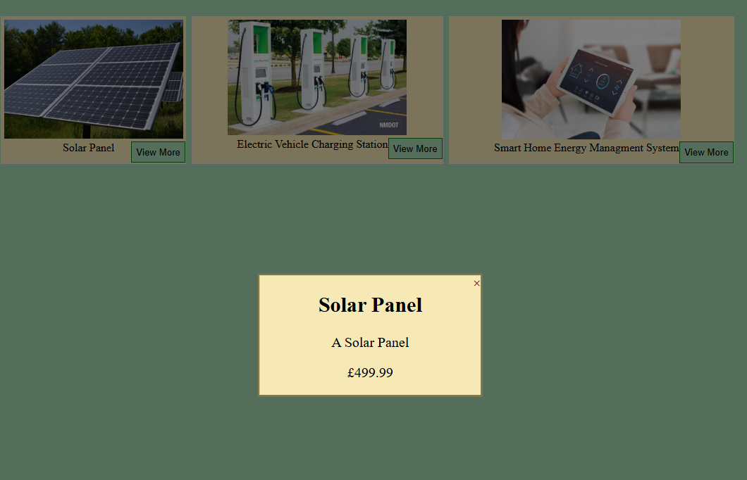 | None
Test Navigation bar functionality. | All the navigation bar buttons clicked. | Each Navigation button will direct the user to the corresponding page. | Every Navigation button directs the user to the correct page.  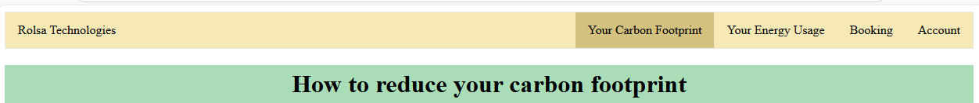 | None
Test if carbon footprint calculator is displayed. | None | The carbon footprint calculator is displayed in the middle of the page. | The carbon footprint calculator is displayed properly.  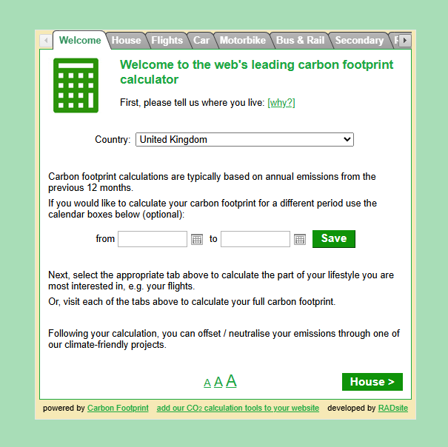 | None
Test if the page has information relating to how to reduce your carbon footprint. | None | Page displays information about how to reduce your carbon footprint. | No information is displayed. | Add information about how to reduce your carbon footprint.
Test is booking page displays when user is not logged in. | None | Page redirects to login page. | User is redirected to the sign in page. | None
Test if the user can select whether they would like to book a consultation or installation. | Button for consultation clicked, button for Installation clicked. | Chosen option is outlined and a list of products will be displayed underneath. | Selected product is outlined and a list of products is displayed underneath. | None
Test if user can select a product to book. | Button for each product clicked. | Each product should be outlined when the user clicks it, only one product should be able to be selected. | Clicked product is outlined, only one product can be selected at a time.  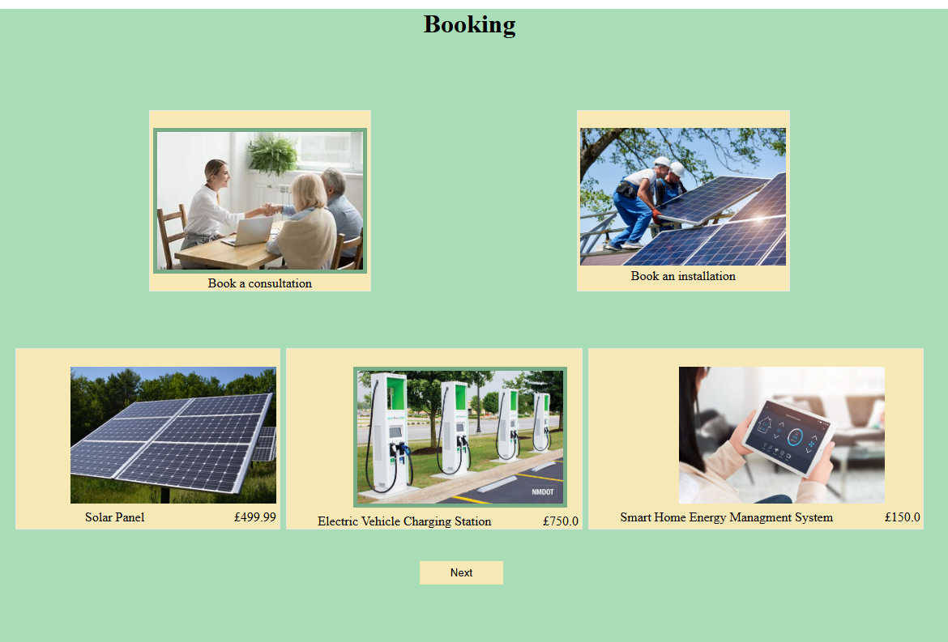 | None
Test if “Next” button is displayed underneath when a product is selected. | Button for product clicked. | The “Next” button should be displayed underneath the products, to prompt the user to go to the payment page. | “Next” button is displayed underneath products. | None
Test if “Next” button is functional. | “Next” button clicked. | The user should be redirected to a payment page after clicking the button. | User is redirected to the payment page on click. | None
Test if Payment page is displayed. | None | Payment page is displayed with form to pay. | Payment page is displayed. | None
Check if the correct product details are displayed. | Solar Panel,  Installation | The product name, booking type, and booking price should be displayed and valid. | All details are displayed and correct.  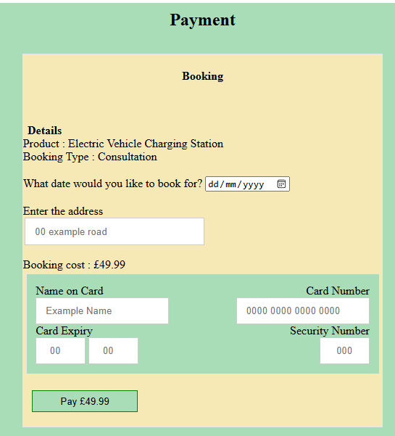 | None
Test if user can input erroneous dates | 42/03/2026,  12/14/2026,  122429,  12-06-2022 | Dates should not be accepted as they do not match the format needed. | Dates are not accepted. | None
Test if user can enter extreme values for the date input. | 03/03/1995,  03/03/2070 | Both dates should not be accepted as they are too far away from the current date. | Past dates are not accepted, however any future date is accepted. | Add a maximum date to ensure users cannot book for an extremely distant date.
Test if the user can input an invalid format for an address. | My house,  55555, | Both inputs should not be accepted as they do not resemble a house address. | Both inputs are accepted. | Add a formatting check to ensure the input starts with a number.
Test if user can enter numbers/invalid charaters into the name input. | 5153,  Mynam3,  @#[]h,  L@g3n,  “My “”name” | All inputs should not be accepted as they are not valid names. | All the inputs are accepted. | Add a format check to ensure only characters can be inputted.
Test if user can enter invalid card numbers. | 4442 0000 oooo TTTT,  myCardNumber,  9959,  6677706059594 | All inputs should not be accepted as they are not in a valid card number format. | All inputs are not accepted as they do not meet the valid format. | None
Test if users can enter valid card numbers | 4958 5902 0295 0295 | Card number should be accepted. | Card number is accepted. | None
Test if users can enter erroneous data in the card expiry. | 44, 94  02, 00  00, 25  January, 2026 | All card expiries should not be accepted | All card expiries except Test 3 were not accepted. | Add a minimum number check to the month input.
Test if users can enter extreme data in the card expiry. | 05, 94  12,04  05,22 | All card expiries should not be accepted as they are extreme dates. | All card expiries are not accepted. | None
Test if users can enter erroneous data into the Security Number input. | Five,  00000,  2,  “” | All security numbers should not be accepted. | All security numbers are not accepted. | None
Test if payment button is functional | 25/04/2025  44 My House  Name  4958 5902 0295 0295  05 25  555 | User should be redirected to a “payment complete” page, and the booking details should be inputted into the database. | User is directed to a payment completed page and all details are inputted into the database. | None
Test if account page is displayed. | None | Account page should display account data and booking data. | Both account and booking data are displayed. | None
Test if booking data is correctly displayed. | Booking data:  Solar Panel  Installation  25 /04/2025  44 My House | Account page should display the correct booking data in a table. | Booking data is correctly displayed and valid.  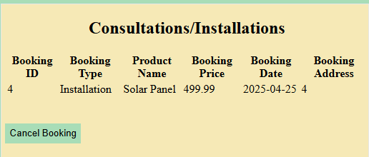 | None
Test if “Cancel Booking” button is functional. | “Cancel Booking” button clicked. | A pop-up should appear. | Pop-up appeared. | None
Test if pop-up information is displayed. | “Cancel Booking“ button clicked. | Pop-up should allow the user to input a Booking ID and click a button to enter. | Pop-up asks user for booking id and button is displayed. | None
Test invalid datatypes in Booking ID input | One,  ~~~,  #5 | Only numbers should be allowed to be entered. | Only numbers can be entered. | None
Test erroneous data in Booking ID input | 52,  42,  700 | An alert should show up telling the user that the booking ID they inputted is invalid. | An alert shows up if the user has inputted a booking ID that they do not have. | None
Test if the “Your data” display displays the correct user data. | myemail@email.com  myusername  Mypassword1234 | The data should be displayed under “Your data”. The password should be hidden. | All data is correct and password is hidden.  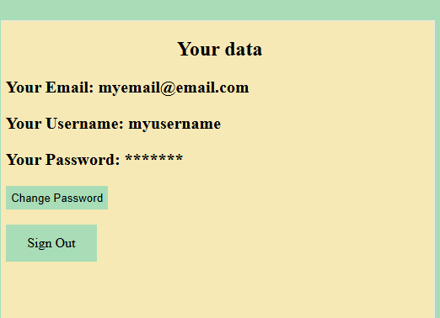 | None
Test if the “Change Password” button is functional. | “Change Password” button is clicked. | A pop-up should appear with an input for the users old password, new password, and retype the new password. | The pop-up shows with all the correct inputs.  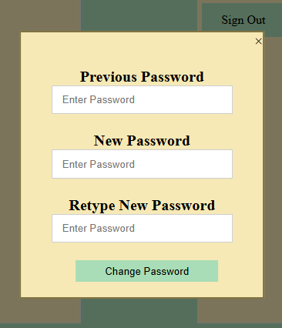 | None
Test if the Retype password check is functional | New password = Mynewpassword1234  Retype password = “Myoldpassword1234”  New password = Mynewpassword1234  Retype password = “Mynewpassword1234” | The first test should return an alert telling the user that the passwords do not match.  The second test should be accepted and the password should be changed. | The first test returns an appropriate alert.  The second test changes the users password. | None
Test if the password was correctly changed. | myusername  Mynewpassword1234 | The credentials should be accepted and the user should be logged in. | User is logged into their account and redirected to the account page. | None
Test if the “Sign Out” button is functional. | “Sign Out” button is clicked. | The user should be logged out and returned to the login page. | User is logged out and returned to the login page. | None
Test if the Sign-Up page is displayed. | None | The page should display a sign-up form to register an account. | The page displays a sign-up form. | None
Test the Email input with erroneous data. | Myemail  12456email | The email should not be accepted. | The email is not accepted and the user is told to include an @ in their email address. | None
Test the Email input with extreme data. | myeeeeeeeeeeeeeeeeeeeeeeeeeeeeeeeeeeeeeeeeeeeeeeeeeeeeeeeeeeeeeeeeeeeeeeeeeeeeeeeeeeeeeeeeeeemail@email.com | Email should not be accepted as it is too long. | Email is accepted. | Add a length check to the email.
Test the Username input with extreme data. | M,  myusernameeeeeeeeeeeeeeeeeeeeeeeeeeeeeeeeeeeeeeeeeeeeeeeeeeeeeeeeeeeeeeeeeeeeeeeeeeeeeeeeeeeeeeeeeeeeee | Usernames should not be accepted as they are too short/long. | First username is not accepted as it is too short, however the second username is accepted. | Add a length check to the username.
Test the password with erroneous data. | mypass  mypassword124 | Passwords should not be accepted as they do not include a capital letter, numbers and need to be a minimum of 8 characters long. | Both passwords are not accepted. | None
Test the Retype password input. | Password = Mypassword1234  Retype Password = Mypassword1111  Password = Mypassword1234  Retype Password = Mypassword1234 | Test 1 should not be accepted as the passwords do not match, however test 2 should be accepted as they do match. | Test 1 isn’t accepted,  Test 2 is accepted. | None
Test the “Sign Up” button. | “Sign Up” button is clicked. | The button should redirect the user to the login page, and the account should be made. | User is redirected to the login page and the account is entered into the database. | None
Test the “Already have an account? Sign In” button. | “Sign In” button is clicked. | User should be redirected to the Sign in page. | User is redirected to the Sign in page. | None
Test the Username input. | Valid account =  username = “myusername”  password = “Mynewpassword1234”  Invalid account =  Username = “user”  Password = “Password12” | Test 1 should allow the user to log in.  Test 2 should not allow the user to log in and return an alert telling the user that they are using an incorrect email/username and password. | Test 1 lets the user log in.  Test 2 does not let the user log in and returns an appropriate alert. | None
Test the Email input. | Valid account =  email = “myemail@email.com”  password = “Mynewpassword1234”  Invalid account =  email = “email@email.com”  Password = “Password12” | Test 1 should allow the user to log in with the email.  Test 2 should not allow the user to log in and should return an alert telling the user that they are using an incorrect email/username and password. | Test 1 allows the user to log in with the valid email.  Test 2 does not allow the user to log in and returns a valid response. | None
Test the “Login” button. | “Login” button is pressed. | The user should be redirected to the Account page and logged in if the inputted data is valid. | The user is redirected to the Account page and logged in. | None
Add more rows and tables as required.

